Name: Shekhar Chaudhary

Date: 10/28/2024

Assignment: 1-4 Final Project Review: Shapes and Image Selection

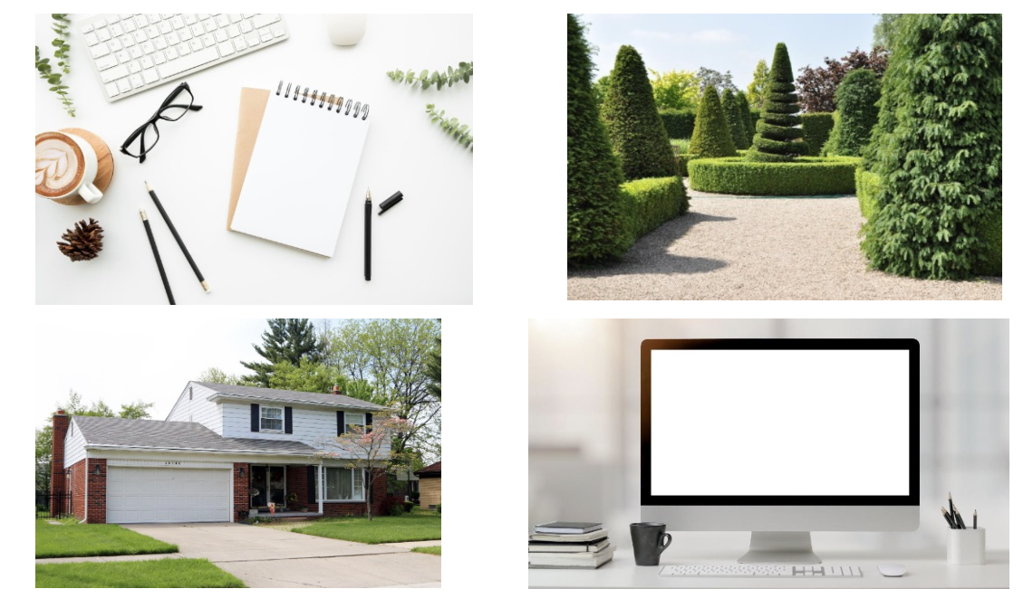

3D Shape Analysis for the Selected 2D Image

I have chosen the image of the desk with a computer monitor, coffee mug, keyboard, and notebook from the second screenshot.

1. Explanation of 3D Shapes

To replicate this image in 3D, we can break down the major objects into basic geometric shapes:

1. Computer Monitor:

This can be represented by a combination of a box for the screen and a tapered cylinder for the stand. The box represents the rectangular display, while the tapered cylinder accurately models the stand’s shape.

1. Coffee Mug:

The mug can be formed using a cylinder for the body and a torus for the handle. The cylinder creates the main body, while the torus replicates the curved handle.

1. Keyboard:

This can be modeled using a box, as it is primarily rectangular and flat.

1. Notebook:

The notebook can be represented using a prism shape, which closely resembles the rectangular form of a closed notebook.

1. Pen Holder:

This object could be created using a cylinder for the main body and small boxes to represent any pens sticking out.

These shapes collectively represent the key objects in the image while maintaining geometric accuracy.

2. Multiple Shape Construction

The computer monitor is an example that would require multiple shapes to replicate. It needs a box for the screen and a tapered cylinder for the stand. This combination is essential to achieve a more realistic 3D model of the monitor, as it captures both the flat screen and the tapering nature of the stand.

3. Simplification in 3D Replication

For simplification, some objects could be combined or omitted. For example:

* Details on the keyboard (like individual keys) could be represented as a single flat plane to reduce complexity.
* The pen holder could be simplified by not including individual pens, using just a cylinder to represent the holder itself.

Overall, simplifying these elements could still maintain the essence of the scene while reducing the complexity of the 3D replication.